# 

# *WEB TECHNOLOGY PROGRAMMING LABORATORY*

# *PRACTICAL FILE*

# SUBMITTED BY : ANMOL SINGH

# ROLL NO : 1921011/1905307

# SECTION : D2ITA1

# SUBMITTED TO : Pf. HANIT KAUR

# BATCH: 2019-23

# *INDEX*

|  |  |  |
| --- | --- | --- |
| **SR.NO.** | **TOPIC** | **PAGE NO.** |
| 1 | Create a simple web pages by writing HTML using a simple text editor, notepad.  Demonstrate the following components of the web page:  Page title and headings  Paragraph and inline images | 2-3 |
| 2 | Demonstrate the use of links, lists, and tables in html. You should be able to link separate pages and create named links within a document , using them to build a “table of contents”. | 3-5 |
| 3 | Create a simple forms in HTML and demonstrate the use of various form elements like input box, textarea, submit and radio buttons etc. | 5-7 |
| 4. | Demonstrate the use of cascading style sheets(CSS) (inline, internal and external) to specify various aspects of style, such as colours and text fonts and sizes, in html document. | 7-9 |
| 5. | Creation of web pages using HTML5 and CSS3 | 9-15 |
| 6. | Demonstrate the use of bootstrap framework | 15-21 |
| 7. | Creating a web page using PHP | 21-23 |

PRACTICAL 1: Demonstrate the following components of the web page: Page titles and Headings Paragraphs and Inline images

<!DOCTYPE html>

<html>

<body>

<title>My first webpage</title>

<h3>big</h3><br><h2>bigger</h2>

<br>

<h1>biggest</h1>

<p>One of the best html learning site:</p>

<img src="w3schools.jpg" alt="W3Schools.com" width="104" height="142">

<a href="https://www.w3schools.com">Must visit</a>

</body>

</html>

**OUTPUT:**



PRACTICAL 2: Demonstrate the use of Links, Lists and Tables in HTML. You should be able to link separate pages and create named links within a document, using them to build a “table of contents”.

<!DOCTYPE html>

<html>

<body>

<h1>Basic HTML Table</h1>

<style>

table, th, td {

border: 1px solid black;

}

</style>

<table style="width:80%"> <table style="background-color:powderblue;">

<tr>

<th>Firstname</th>

<th>Lastname</th>

<th>Class</th>

</tr>

<tr>

<td>Anmol</td>

<td>Singh</td>

<td>ITA</td>

</tr>

<tr>

<td>Ashu</td>

<td>Sharma</td>

<td>ITA</td>

</tr>

<tr>

<td>Ankit</td>

<td>Singh</td>

<td>ITB</td>

</tr>

</table>

<h2 style="background-color:pink;">Ordered List</h2>

<ol>

<li>Friends</li>

<li>Brothers</li>

</ol>

<h2 style="background-color:Yellow;">Unordered list</h2>

<ul>

<li>Ludhiana</li>

<li>Amritsar</li>

</ul>

<h3>for updates keep visiting </h3>

<a href="https://www.gndec.ac.in">Here is a link</a>

</body>

</html>

**OUTPUT:**

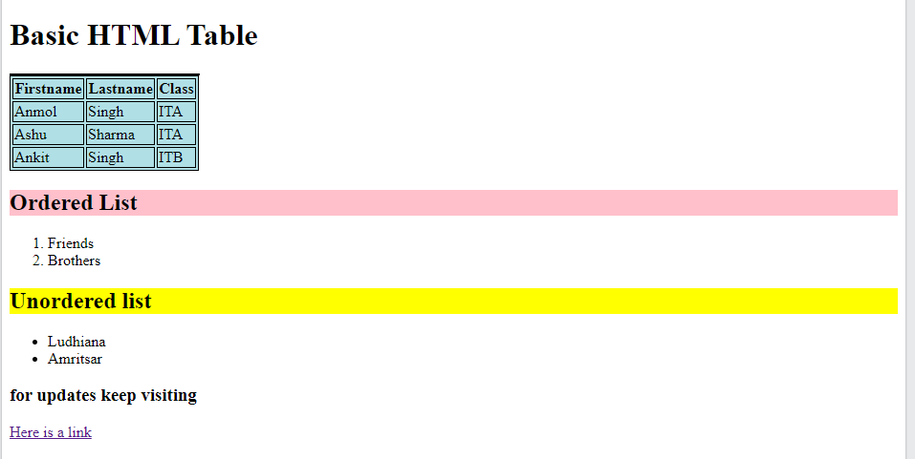

PRACTICAL 3: Create a simple forms in HTML and demonstrate the use of various form elements like input box, textarea, submit and radio buttons etc.

<!DOCTYPE html>

<head></head>

<body>

<form>

<label for="fname">First name:</label><br>

<input type="text" id="fname" name="fname"><br>

<label for="lname">Last name:</label><br>

<input type="text" id="lname" name="lname"><br>

<br>

<label for="M.no.">Mobile number:</label><br>

<input type="text" id="M.no." name="M.no."><br><br>

<label for="state">State:</label><br>

<input type="text" id="state" name="state">

<br><br>

Gender <br> <input type="radio" id="male" name="gender" value="male">

<label for="male">Male</label><br>

<input type="radio" id="female" name="gender" value="female">

<label for="female">Female</label><br>

<input type="radio" id="other" name="gender" value="other">

<label for="other">Other</label><br><br>

What is your hobby <br>

<input type="checkbox" id="hobby1" name="hobby1" value="traveling">

<label for="hobby1"> I love traveling</label><br>

<input type="checkbox" id="hobby2" name="hobby2" value="sports">

<label for="hobby2"> I like to play sports</label><br>

<input type="checkbox" id="hobby3" name="hobby3" value="watching">

<label for="hobby3"> I like to watch movies</label><br><br>

your feedback<br>

<textarea>pls give your feedback</textarea><br><br>

<input type="submit" value="Submit">

</html>

</body>

</form>

**OUTPUT:**

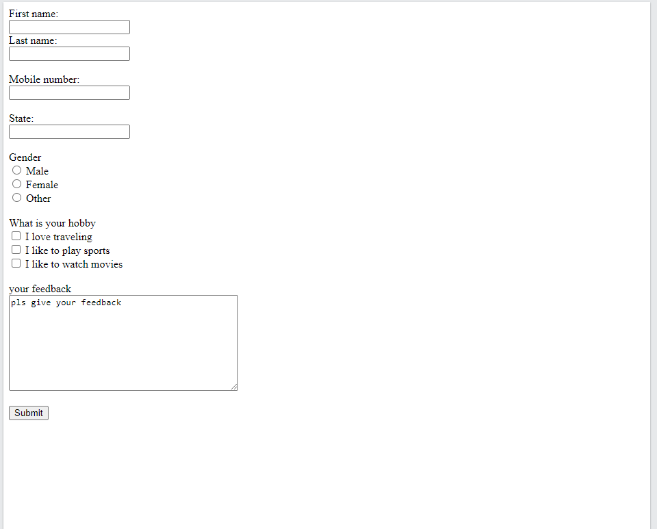

**PRACTICAL 4:** Demonstrate the use of cascading style sheets(CSS) (inline, internal and external) to specify various aspects of style, such as colours and text fonts and sizes, in html document

<!DOCTYPE html>

<html>

<head>

<style>

body {

background-color: lightblue;

}

h{

color:black;

text-align: center;

font-size:60px;

}

h1 {

color: black;

text-align: center;

}

p {

font-family: verdana;

font-size: 20px;

}

</style>

</head>

<body>

<h style="background-color:lightpink;">we win together against coronavirus</h>

<h1 style="background-color:DodgerBlue;">keep following precautions</h1>

<p style="background-color:Tomato;">1.whenever go outside always use mask <br>

2.use hand sanitizers and handwash/soap to clean your hand <br>

3.Stay home stay safe<br>

4.maintain social distancing

</p>

</body>

</html>

**OUTPUT:**

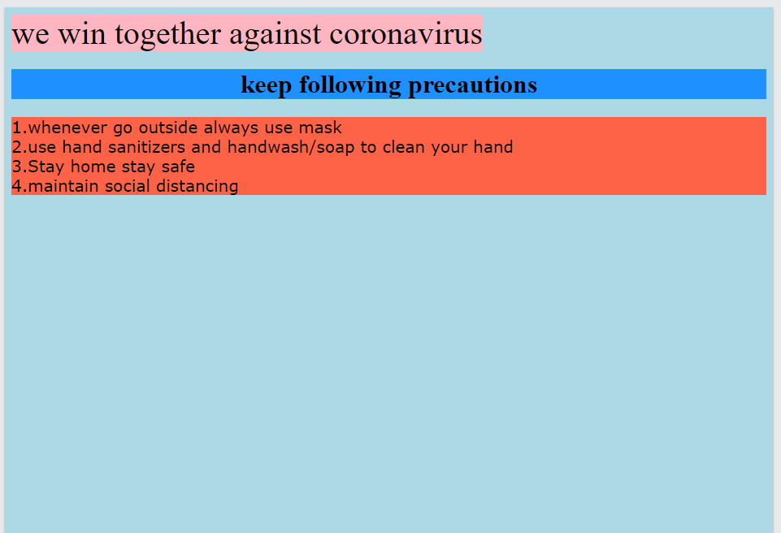

**PRACTICAL 5:** Creation of web pages using HTML5 and CSS3

<!DOCTYPE html>

<html lang="en">

<head>

<meta charset="UTF-8">

<meta http-equiv="X-UA-Compatible" content="IE=edge">

<link href="https://fonts.googleapis.com/css?family=Baloo+Bhai&display=swap" rel="stylesheet">

<meta name="viewport" content="width=device-width, initial-scale=1.0">

<title>Practical 5</title>

</head>

<style>

body{

background-image: url('nature.jpg');

background-repeat: no-repeat;

font-family: 'Baloo Bhai', cursive;

color: white;

margin: 0px;

padding: 0px;

}

nav{

color: white;

}

.left {

display: inline-block;

position: absolute;

left: 60px;

top: 20px;

}

.left div {

line-height: 19px;

font-size: 26px;

text-align: center;

}

.mid {

display: block;

width: 36%;

margin: 29px auto;

}

.right {

position: absolute;

right: 34px;

top: 43px;

display: inline-block;

}

.navbar {

display: inline-block;

}

.navbar li {

display: inline-block;

font-size: 25px;

}

.navbar li a {

color: white;

text-decoration: none;

padding: 34px 23px;

}

.navbar li a:hover,

.navbar li a.active {

text-decoration: underline;

color: rgb(87, 192, 119);

}

.btn {

font-family: 'Baloo Bhai', italic;

margin: 0px 9px;

background-color: green;

color: white;

padding: 4px 14px;

border: 2px solid grey;

border-radius: 10px;

font-size: 20px;

cursor: pointer;

}

.btn:hover {

background-color: rgb(31, 30, 30);

}

.container {

border: 2px solid white;

margin: 106px 80px;

padding: 75px;

width: 33%;

border-radius: 28px;

}

.form-group input {

font-family: 'Baloo Bhai', cursive;

text-align: center;

display: block;

width: 508px;

padding: 1px;

border: 2px solid black;

margin: 11px auto;

font-size: 25px;

border-radius: 8px;

}

.container h1 {

text-align: center;

}

.container button {

display: block;

width: 74%;

margin: 20px auto;

}

</style>

<body>

<header class="header">

<div class="left">

<div>Back To Nature</div>

</div>

<!-- Mid box for navbar -->

<div class="mid">

<ul class="navbar">

<li><a href="#" class="active">Home</a></li>

<li><a href="#">About Us</a></li>

<li><a href="#">Blog</a></li>

<li><a href="#">Contact Us</a></li>

</ul>

</div>

<!-- Right box for buttons -->

<div class="right">

<button class="btn">Call Us Now</button>

<button class="btn">Email Us</button>

</div>

</header>

<div class="container">

<h1>Join to Save the nature</h1>

<form action="noaction.php">

<div class="form-group">

<input type="text" name="" placeholder="Enter your Name">

</div>

<div class="form-group">

<input type="text" name="" placeholder="Enter your Age">

</div>

<div class="form-group">

<input type="text" name="" placeholder="Enter your Gender">

</div>

<div class="form-group">

<input type="text" name="" placeholder="Enter your Phone Number">

</div>

<button class="btn">Submit</button>

</form>

</div>

</body>

</html>

**OUTPUT:**

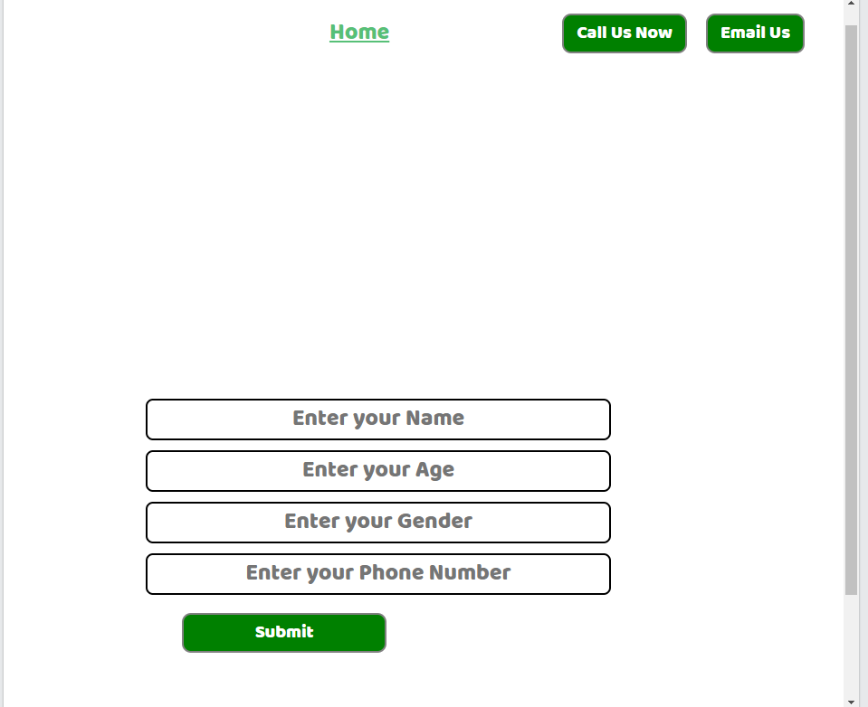

**PRACTICAL 6:** Demonstrate the use of bootstrap framework

<!DOCTYPE html>

<html lang="en">

<head>

<meta charset="UTF-8" />

<meta http-equiv="X-UA-Compatible" content="IE=edge" />

<meta name="viewport" content="width=device-width, initial-scale=1.0" />

<title>Practical 6</title>

<link

rel="stylesheet"

href="https://cdn.jsdelivr.net/npm/bootstrap@4.6.0/dist/css/bootstrap.min.css"

integrity="sha384-B0vP5xmATw1+K9KRQjQERJvTumQW0nPEzvF6L/Z6nronJ3oUOFUFpCjEUQouq2+l"

crossorigin="anonymous"

/>

</head>

<body style="padding: 50px">

<nav class="navbar navbar-expand-lg navbar-dark bg-dark">

<a class="navbar-brand" href="#">Navbar</a>

<button

class="navbar-toggler"

type="button"

data-toggle="collapse"

data-target="#navbarTogglerDemo02"

aria-controls="navbarTogglerDemo02"

aria-expanded="false"

aria-label="Toggle navigation"

>

<span class="navbar-toggler-icon"></span>

</button>

<div class="collapse navbar-collapse" id="navbarTogglerDemo02">

<ul class="navbar-nav mr-auto mt-2 mt-lg-0">

<li class="nav-item active">

<a class="nav-link" href="#"

>Home <span class="sr-only">(current)</span></a

>

</li>

<li class="nav-item">

<a class="nav-link" href="#">Link</a>

</li>

<li class="nav-item">

<a

class="nav-link disabled"

href="#"

tabindex="-1"

aria-disabled="true"

>Disabled</a

>

</li>

</ul>

<form class="form-inline my-2 my-lg-0">

<input

class="form-control mr-sm-2"

type="search"

placeholder="Search"

/>

<button class="btn btn-outline-success my-2 my-sm-0" type="submit">

Search

</button>

</form>

</div>

</nav>

<br />

<div class="alert alert-success" role="alert">

<h4 class="alert-heading">Well done!</h4>

<p>

Aww yeah, you successfully read this important alert message. This

example text is going to run a bit longer so that you can see how

spacing within an alert works with this kind of content.

</p>

<hr />

<p class="mb-0">

Whenever you need to, be sure to use margin utilities to keep things

nice and tidy.

</p>

</div>

<br />

<form class="needs-validation" novalidate style="margin: 0 50px">

<div class="form-row">

<div class="col-md-6 mb-3">

<label for="validationTooltip01">First name</label>

<input

type="text"

class="form-control"

id="validationTooltip01"

placeholder="Mark"

required

/>

<div class="valid-tooltip">Looks good!</div>

</div>

<div class="col-md-6 mb-3">

<label for="validationTooltip02">Last name</label>

<input

type="text"

class="form-control"

id="validationTooltip02"

placeholder="Zukerberg"

required

/>

<div class="valid-tooltip">Looks good!</div>

</div>

</div>

<div class="form-row">

<div class="col-md-6 mb-3">

<label for="validationTooltip03">City</label>

<input

type="text"

class="form-control"

id="validationTooltip03"

required

/>

<div class="invalid-tooltip">Please provide a valid city.</div>

</div>

<div class="col-md-3 mb-3">

<label for="validationTooltip04">State</label>

<select class="custom-select" id="validationTooltip04" required>

<option selected disabled value="">Choose...</option>

<option>...</option>

</select>

<div class="invalid-tooltip">Please select a valid state.</div>

</div>

<div class="col-md-3 mb-3">

<label for="validationTooltip05">Zip</label>

<input

type="text"

class="form-control"

id="validationTooltip05"

required

/>

<div class="invalid-tooltip">Please provide a valid zip.</div>

</div>

</div>

<button class="btn btn-primary" type="submit">Submit form</button>

</form>

</body>

</html>

**OUTPUT:**

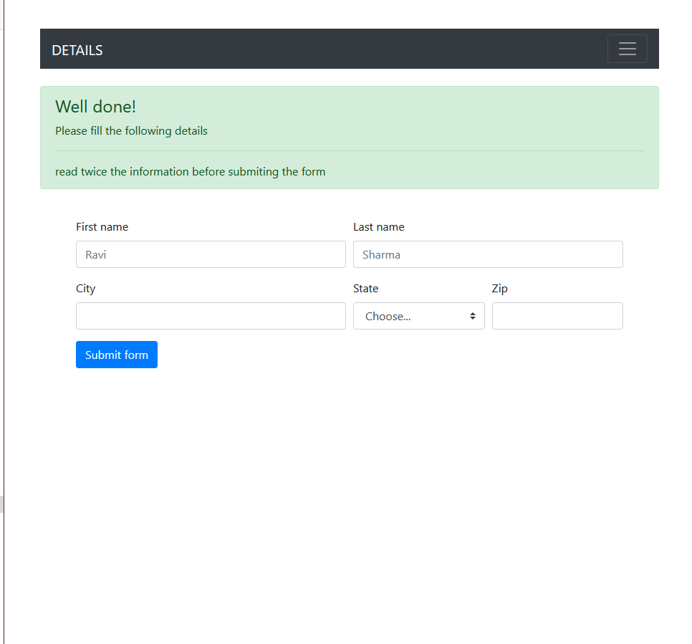

**PRACTICAL 7:** Creating a web page using PHP

<html>

<head>

<link rel="stylesheet" href="1921156_prac7_css.css">

</head>

<form name="frm" action="1921156_prac7_php.php" method="post">

<center>

<h1><u>Please fill your details and your feedback.</u> </h1> <br>

<span>Name:</span><br> <input type="text" name="name" size="5" required="">

<br><br>

<span>Phone number:</span><br><input type="text" name="phonenumber" required="">

<br><br>

<span>Address:</span><br>

<input type="text" name="address" required="" >

<br><br>

<span>E-mail address:</span><br>

<input type="email" name="email" required="">

<br><br>

<span>Feedback:</span><br>

<textarea rows="8" cols="55" name="feedback" required="">

</textarea><br><br>

<input type="submit" name="submit" Value="SUBMIT">&nbsp

<input type="reset" Value="RESET"></center>

</form>

</body>

</html>

<?php

$conn= mysqli_connect("localhost","root","","feedback");

if(isset($_POST['submit'])){

$name=$_POST['name'];

$phonenumber=$_POST['phonenumber'];

$address=$_POST['address'];

$email=$_POST['email'];

$feedback=$_POST['feedback'];

$query="insert into feedback_table(name,phonenumber,address,email,feedback)

values('$name','$phonenumber','$address','$email','$feedback')";

$run=mysqli_query($conn,$query);

if($run){

echo "Feedback posted";

}

else{

echo "Error:" .mysqli_error($conn);

}

}

?>

**OUTPUT:**

